**Practical 5**

**Reg. no.:** 2147116

**Name:** Ishaan Bose

**1. Describe STaaS.**

Storage as a Service (STaaS) is the practice of using public cloud storage resources to store your data. Using STaaS is more cost efficient than building private storage infrastructure, especially when you can match data types to cloud storage offerings. The key benefit to STaaS is that you are offloading the cost and effort to manage data storage infrastructure and technology to a third-party CSP. This makes it much more effective to scale up storage resources without investing in new hardware or taking on configuration costs. You can also respond to changing market conditions faster. With just a few clicks you can rent terabytes or more of storage, and you don’t have to spin up new storage appliances on your own.

**2. Mention the different storage types offered by the cloud providers and list the example services for each type in GCP/AWS/Azure.**

Storage types:

* **Block storage** breaks data into segmented pieces and distributes them to the storage environment wherever it is most efficient for the platform to do so. This simulates the same functionality as writing data to a standard hard disk drive or solid-state drive. Data remains available for quick access, but it is also costly to maintain and works best for warm or hot data storage.
* **File storage** lists data in a navigable hierarchy, usually a file directory. This is most like the file storage system that you would find on a PC or in cloud storage apps like Microsoft OneDrive. Because it is designed for humans to navigate, file storage is ideal anytime you need to collaborate on a project with other people or businesses. Whether the data is hot or cold doesn’t matter as much. However, file storage does not scale well. The more files you add, the more complex the system becomes and the more difficult it is to navigate.
* **Object-based storage** organizes data by adding meta information to it, making it easy to recognize and retrieve at any time. This type of cloud storage scales up in the most cost-efficient manner, because you can keep adding to it. It is typically the least expensive type of STaaS and best suited for massive amounts of cold media or data files.

AWS:

* Amazon Simple Storage Service (S3)
* Amazon Elastic File System (EFS)
* Amazon FSx
* Amazon Elastic Block Storage (EBS)

GCP:

* Cloud storage
* Filestore
* Persistent Disk
* Local SSD

Azure:

* Azure Blobs
* Azure Files
* Azure Queues
* Azure Tables
* Azure Disks
* Azure NetApp Files

**3. Demonstrate the following: Create a New Block Store and attach it to an VM instance.**

1. To create a new block store, scroll down the navigation pane to Elastic Block Store and click on Volumes.
2. On the new page, click on Create volume.

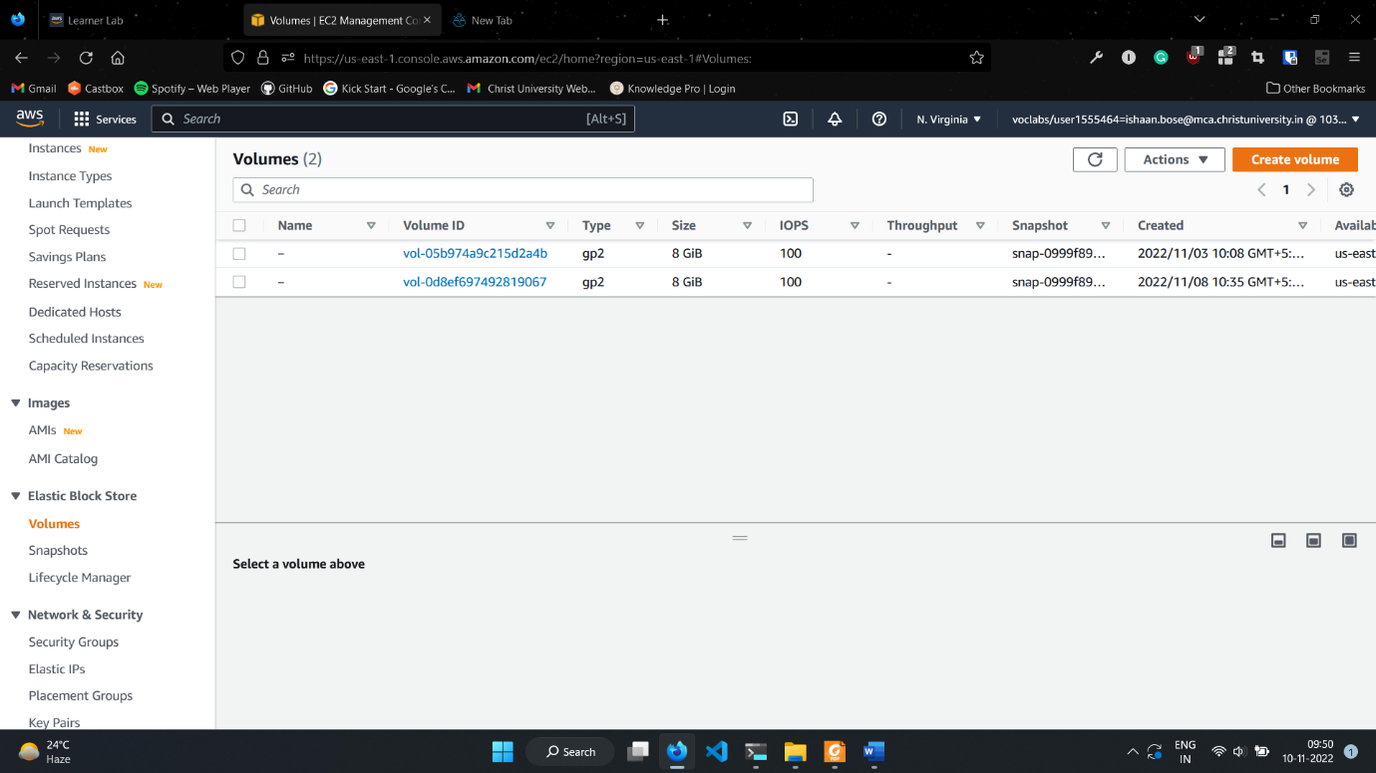

1. Fill in the desired specifications for the new EBS. NOTE: Make sure that availability zone matches the availability zone of the ec2 instance which will be using this EBS.

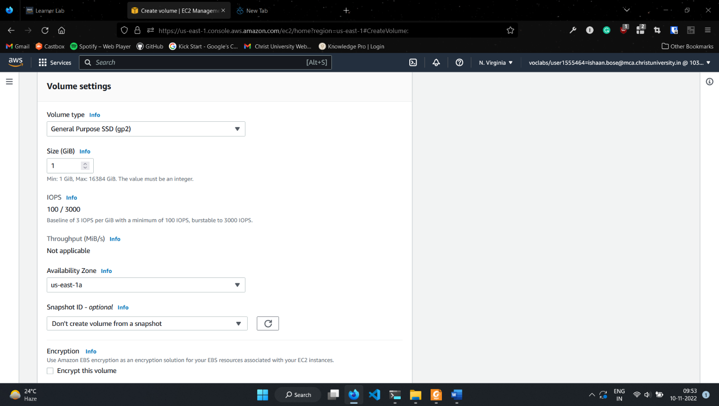

1. Once the new EBS is created, wait for Volume state to be “Available”.
2. Once Available, click on the volume and then on Actions -> Attach volume

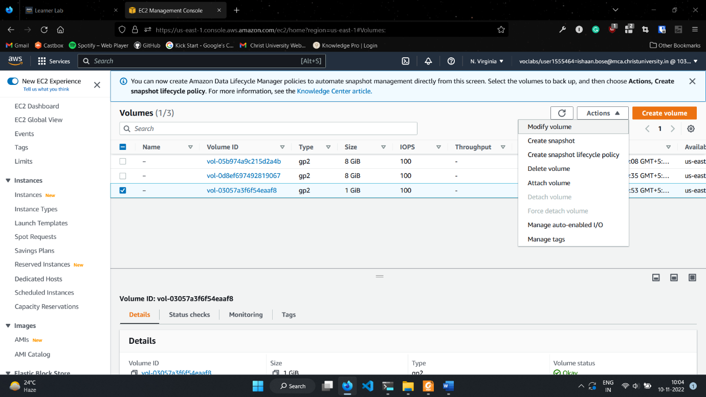

1. Select the desired instance, and provide an appropriate device name.

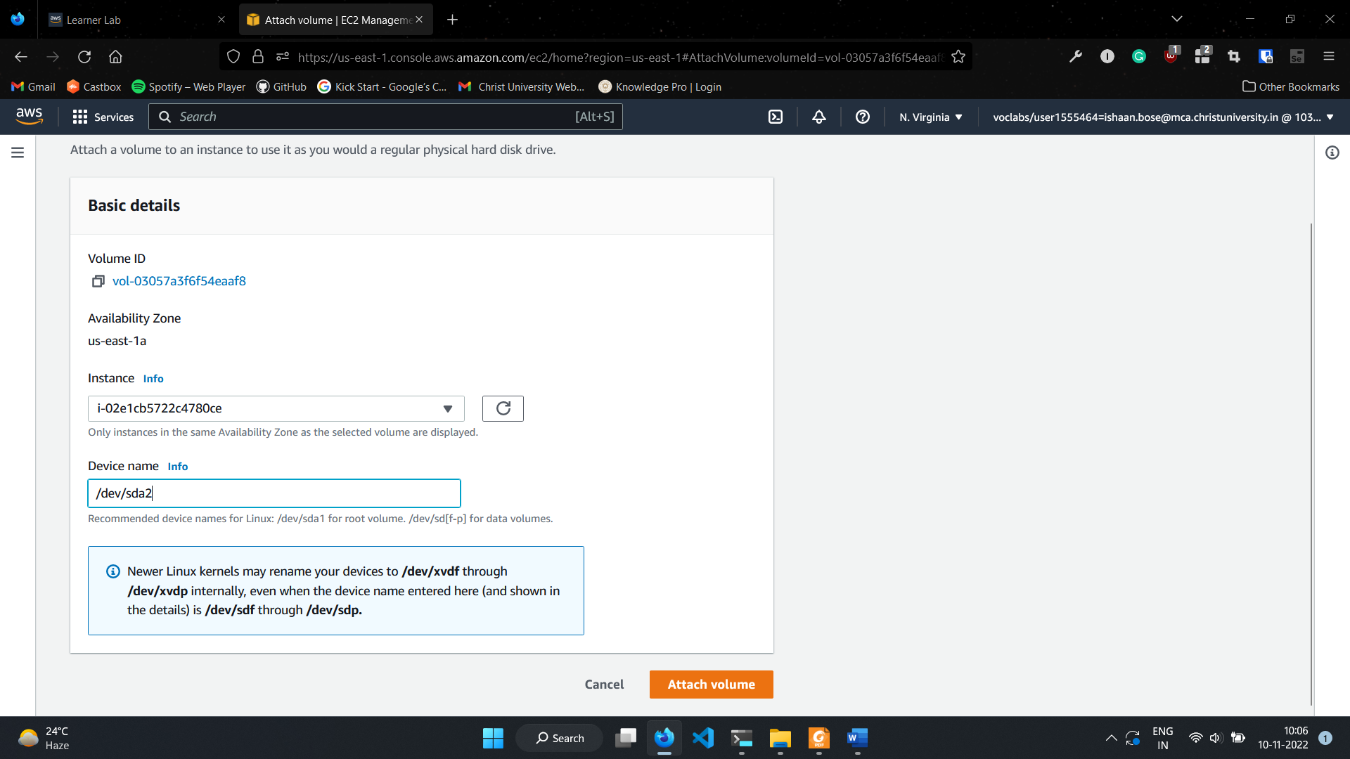

1. Connect to your instance.
2. Run command lsblk to view the instance which has been attached but not mounted.

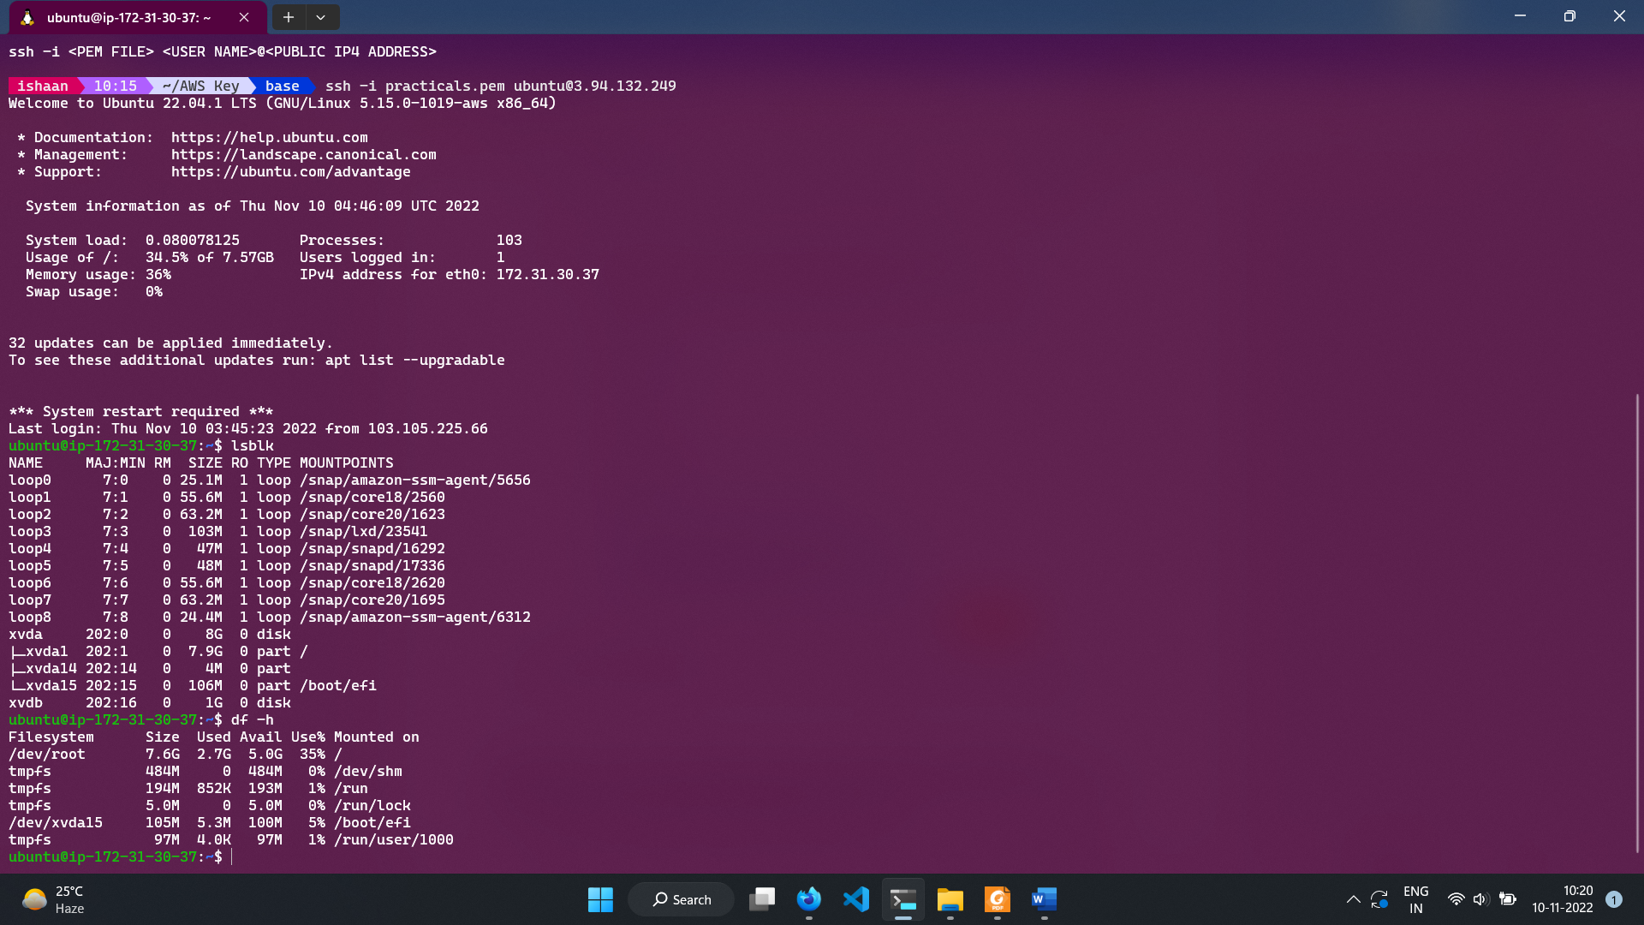

1. Run sudo mkfs -t xfs /dev/xvdb to make file system for the volume

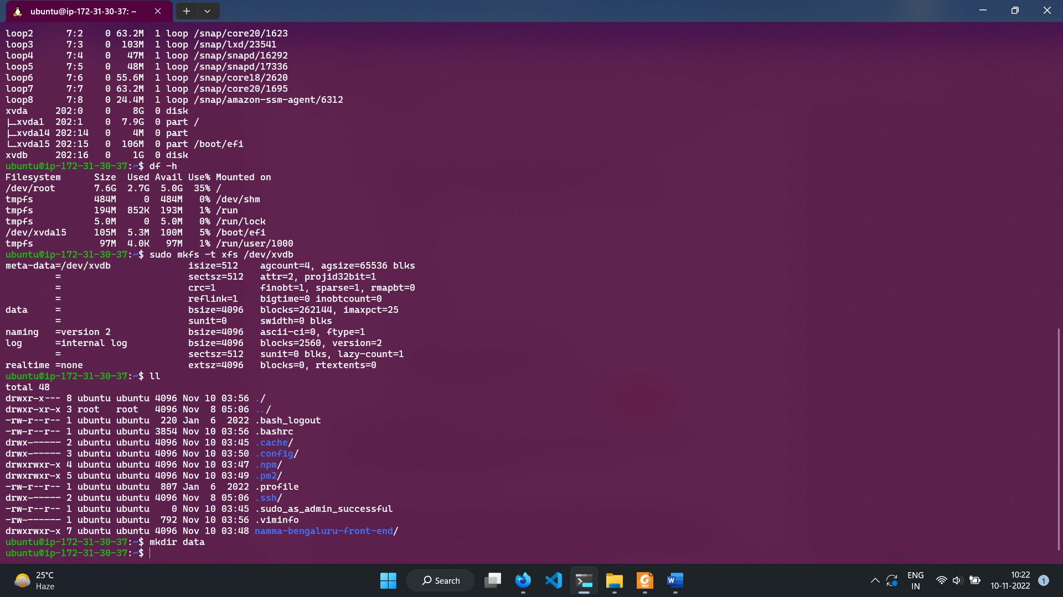

1. Create a directory to mount the volume.
2. Run command: sudo mount /dev/xvdb ./data to mount volume to data dir
3. Run lsblk again to confirm mounting

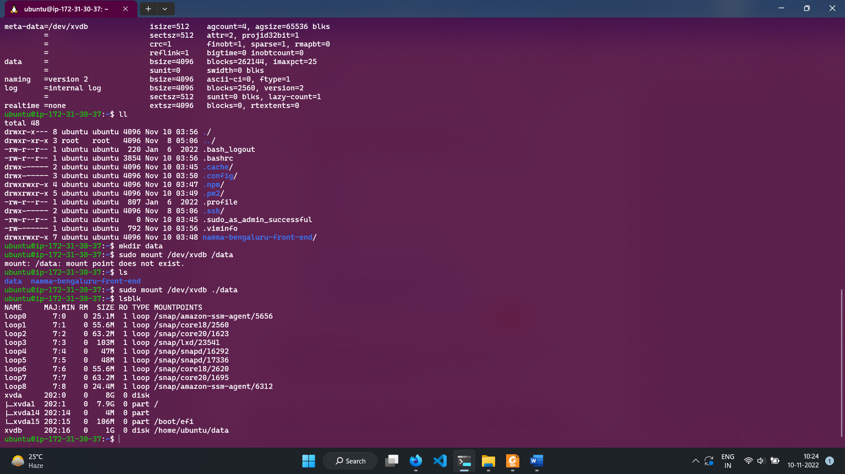

**4. Assume that, an online news agency wants to support their agents and editors for fast publication of the news using cloud technologies. They are expecting a small software application for the news agents and editors for the following requirements.**

1. **Provision to upload the images of the events from venue to the folder named “oimage” present in the cloud storage.**
2. **After the uploading of the image a thumbnail image should be created for the same and it will be stored separately in a folder called “timages” for the selection of the right image for the news feed.**

**Identify a suitable Cloud Storage for the requirement and demonstrate the scenario using python.**

1. Navigate to Amazon S3 console and create a bucket.

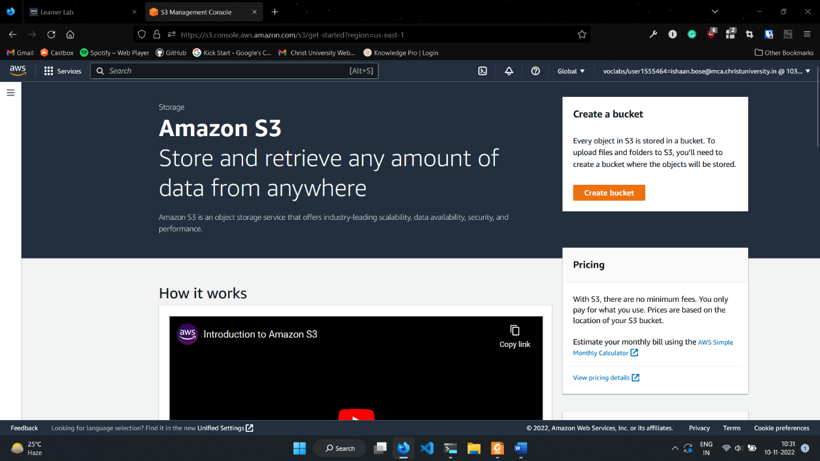

1. Choose an appropriate bucket name and leave all other settings as is.

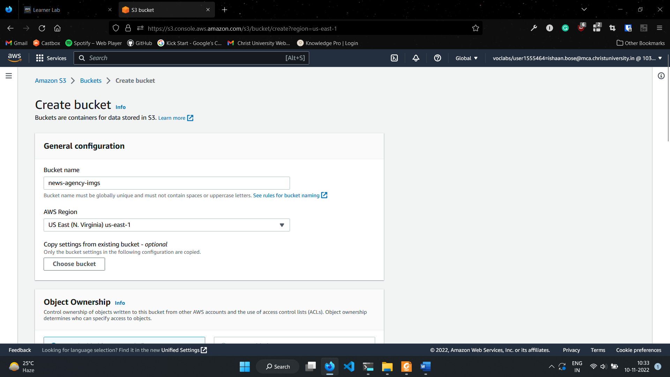

1. Click on the newly created bucket and click on create folder. Give name oimage to it and click on Create folder.

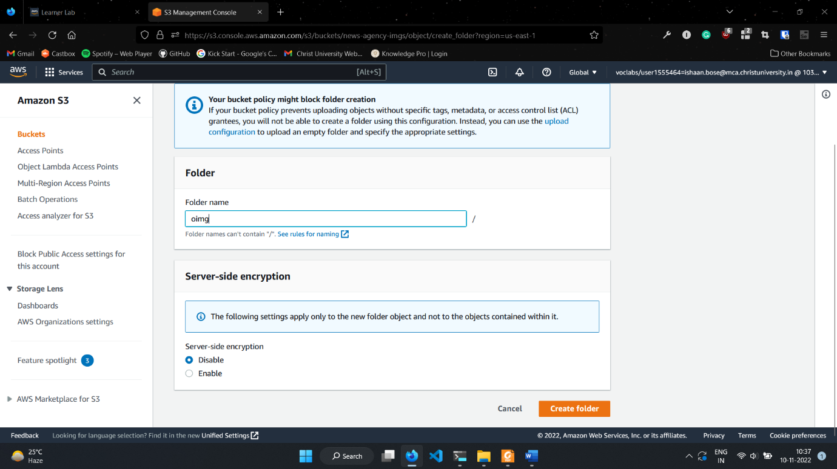

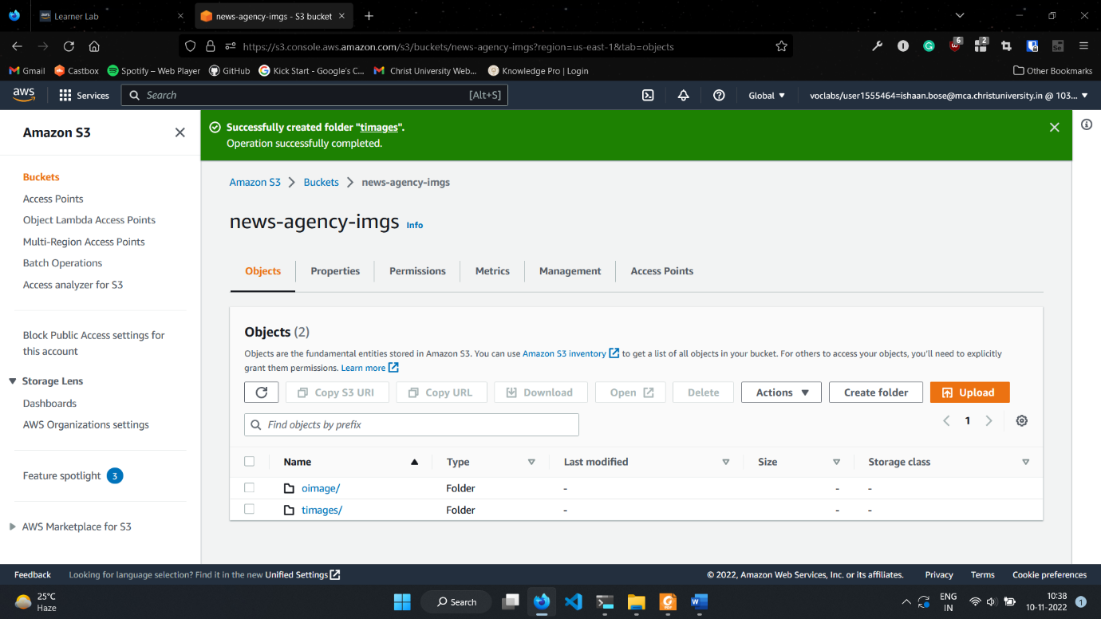

1. Once the folders are created, we can start uploading files to them.
2. For this exercise, we use a python script to allow users to choose which image they want to upload.

Python script:

import boto3

from tkinter import Tk

from tkinter.filedialog import askopenfilenamepath

import cv2

import os

BUCKET_NAME = "news-agency-imgs"

s3_client = boto3.client('s3')

s3_resource = boto3.resource('s3')

Tk().withdraw() *# we don't want a full GUI, so keep the root window from appearing*

filenamepath = askopenfilenamepath() *# show an "Open" dialog box and return the path to the selected filename*

print(filenamepath)

filename = filenamepath.split("/")[-1] *# file name*

print(filename)

s3_resource.meta.client.upload_filename(

    filenamepath, BUCKET_NAME, "oimage/" + filename

) *# uploading image to oimage folder*

print("Uploaded to oimage!")

s3_resource.Object(BUCKET_NAME, "oimage/" + filename).download_filename(f"./.temp/{ filename }") *# downloading image from oimage folder into .temp directory*

print("Downloaded image!")

image = cv2.imread(filenamepath, 1)

thumbnail = cv2.resize(image, (300, 300), interpolation=cv2.INTER_CUBIC) *# downsizing image to size 300x300*

cv2.imwrite(f"./.temp/t_{ filename }", thumbnail) *# writing to .temp file*

s3_resource.meta.client.upload_filename(

    f"./.temp/t_{ filename }", BUCKET_NAME, f"timages/t_{filename}"

) *# uploading to timages folder*

print("Uploaded to timages")

dir = "./.temp"

for f in os.listdir(dir): *# deleting all files in .temp folder*

    os.remove(os.path.join(dir, f))

print("Deleted contents of .temp directory.")